### **Task 4 : The locate command**

1. **Write a script to help you locate a file named umuzi.**

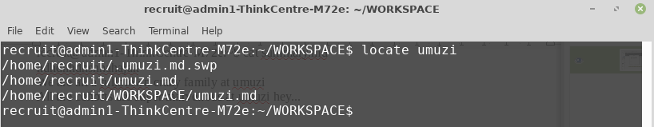

1. **Write a second script that will search for the same file and send the result of the search to a file named search_result.md**

